Software engineering
SOFTWARE: Computer software, or just software, is a collection of computer programs and related data that provides the instructions for telling a computer what to do and how to do it. Software refers to one or more computer programs and data held in the storage of the computer for some purposes. In other words, software is a set of programs, procedures, algorithms and its documentation concerned with the operation of a data processing system. Program software performs the function of the program it implements, either by directly providing instructions to the computer hardware or by serving as input to another piece of software.

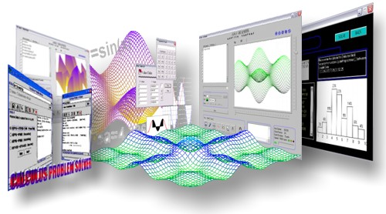

Software engineering (SE): It is the application of a systematic, disciplined, quantifiable approach to the development, operation, and maintenance of software, and the study of these approaches; that is, the application of engineering to software. It is the application of engineering to software because it integrates significant mathematics, computer science and practices whose origins are in engineering. It is also defined as a systematic approach to the analysis, design, assessment, implementation, testing, maintenance and reengineering of software, that is, the application of engineering to software. The term software engineering first appeared in the 1968 NATO Software Engineering Conference, and was meant to provoke thought regarding the perceived "software crisis" at the time.

SOFTWARE DEVELOPMENT LIFE CYCLE: A software development process, also known as a software development life cycle (SDLC), is a structure imposed on the development of a software product. Similar terms include software life cycle and software process. It is often considered a subset of systems development life cycle. There are several models for such processes, each describing approaches to a variety of tasks or activities that take place during the process. Some people consider a life-cycle model a more general term and a software development process a more specific term.
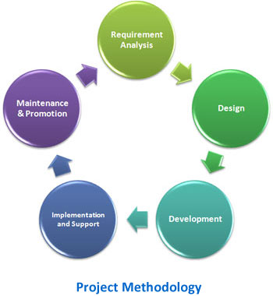
PHASES TO DEVELOP SOFTWARE
1. FEASIBILITY STUDY: A feasibility study’s main goal is to assess the economic viability of the proposed business. The study should provide a thorough analysis of the business opportunity, including a look at all the possible roadblocks that may stand in the way of the cooperative’s success. The outcome of the feasibility study will indicate whether or not to proceed with the proposed venture.
2. REQUIREMENT GATHERING: Requirements analysis in systems engineering and software engineering, encompasses those tasks that go into determining the needs or conditions to meet for a new or altered product, taking account of the possibly conflicting requirements of the various stakeholders, such as beneficiaries or users.
3. DESIGN: Design as a noun informally refers to a plan or convention for the construction of an object or a system (as in architectural blueprints, engineering drawing, business process, circuit diagrams and sewing patterns) while "to design" (verb) refers to making this plan. No generally-accepted definition of "design" exists, and the term has different connotations in different fields .
4. CODING: It refers to an analytical process in which data, in both quantitative form (such as questionnaires results) or qualitative (such as interview transcripts) are categorized to facilitate analysis.
5. TESTING: Software testing is an investigation conducted to provide stakeholders with information about the quality of the product or service under test. Software testing can also provide an objective, independent view of the software to allow the business to appreciate and understand the risks of software implementation.
6. IMPLEMENTATION: Implementation is the realization of an application, or execution of a plan, idea, model, design, specification, standard, algorithm, or policy.
7. MAINTENANCE: Software maintenance in software engineering is the modification of a software product after delivery to correct faults, to improve performance or other attributes. A common perception of maintenance is that it merely involves fixing defects This perception is perpetuated by users submitting problem reports that in reality are functionality enhancements to the system.
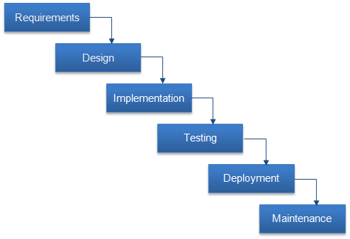

MODELS TO DEVELOP A SOFTWARE :
1.BASIC WATERFALL MODEL: In the waterfall model we start with the feasibility study and move down through the various phases upto Implementation, Testing, Deployment, maintenance and into live environment.In this model ,there is no feedback by user in each phas

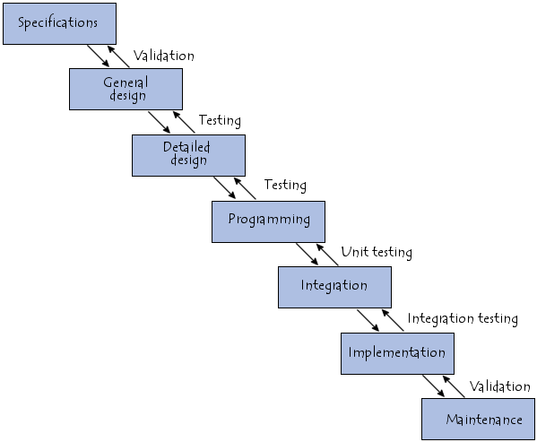
2. ITERATIVE WATERFALL MODEL: Iterative and Incremental development is at the heart of a cyclic software development process developed in response to the weaknesses of the waterfall model. It starts with an initial planning and ends with deployment with the cyclic interactions in between.Iterative and incremental development are essential parts of the Rational Unified Process, Extreme Programming and generally the various agile software development frameworks.
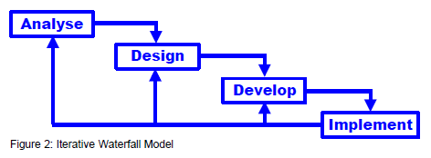

3. PROTOTYPING MODEL: It begins with requirements gathering. Developer and Customers meet and define the overall objectives of the software, identify whatever requirements are known and identify the areas which require further definition. In many instances the client only has a general view of what is expected from the software product. In such a scenario where there is an absence of detailed information regarding the input to the system, the processing needs and the output requirements, the prototyping model may be employed. This model reflects an attempt to increase the flexibility of the development process by allowing the client to interact and experiment with a working representation of the product.
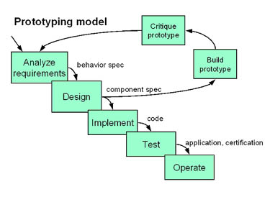

4. SPIRAL MODEL: The spiral model is a software development process combining elements of both design and prototyping-in-stages, in an effort to combine advantages of top-down and bottom-up concepts. Also known as the spiral lifecycle model (or spiral development), it is a systems development method (SDM) used in information technology (IT). This model of development combines the features of the prototyping and the waterfall model. The spiral model is intended for large, expensive and complicated projects.
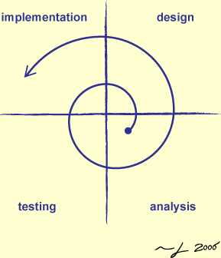

SRS DOCUMENT:
A software requirements specification (SRS) – a requirements specification for a software system – is a complete description of the behavior of a system to be developed and may include a set of use cases that describe interactions the users will have with the software. In addition to a description of the software functions, the SRS also contains non-functional requirements. Non-functional requirements impose constraints on the design or implementation (such as performance engineering requirements, quality standards, or design constraints), and are sometimes referred to as "ilities".
ADVANTAGES:
Enables costing and pricing of the project - A well defined SRS enables software developers to accurately estimate the amount of effort required to build the software product. Function point analysis and SMC are some the techniques adopted for estimating effort.Input for detailed design - A good SRS enables experienced developers to convert the requirements directly to a technical design. For example, a well defined data dictionary can be easily converted to a database specification.
